IS5306: NUMERICAL METHODS

TAKE HOME ASSIGNMENT 1

NAME : FERNANDO S.A.D.S.

REG No. : EG/2020/3929

SEMESTER: 05

DATE : 06/02/2024

Q) Find the root of f(x)= x3-3x-5 by using bisection method. Error tolerance=0.01.

Let,

|  |  |  |  |  |  |
| --- | --- | --- | --- | --- | --- |
| $$f(0)$$ | = | -5 | ; | < | 0 |
| $$f(1)$$ | = | -1 | ; | < | 0 |
| $$f(2)$$ | = | 9 | ; | < | 0 |
|  |  |  |  |  |  |

Therefore, starting interval is [1, 2].

Matlab code;

function root = bisection_method()

% Function definition

f = @(x) x^3 +(3*x) - 5;

% Starting interval

a = 1;

b = 2;

% Error tolerance

error_tolerance = 0.01;

% Check if there's a sign change in the interval

if f(a) * f(b) >= 0

error('No sign change detected in the interval');

end

% Bisection method

while (b - a) > error_tolerance

% Midpoint of the interval

m1 = (a + b) / 2;

% Evaluate the function at the midpoint

func = f(m1);

% Update the interval boundaries

if func < 0

a = m1;

else

b = m1;

end

% Return the approximate root

root = (a + b) / 2;

end

end

Therefore, approximate root = 1.1523

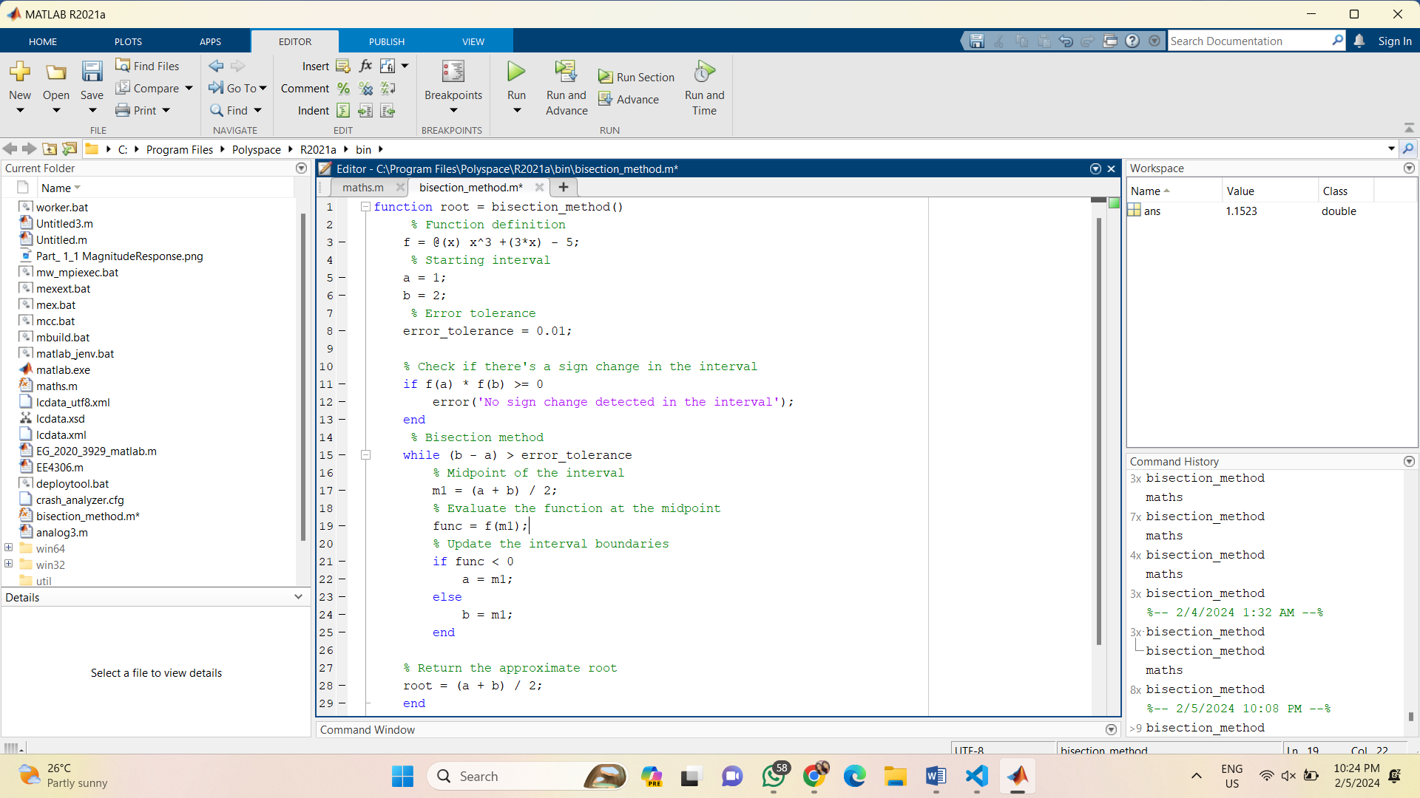

Figure : MATLAB CODE

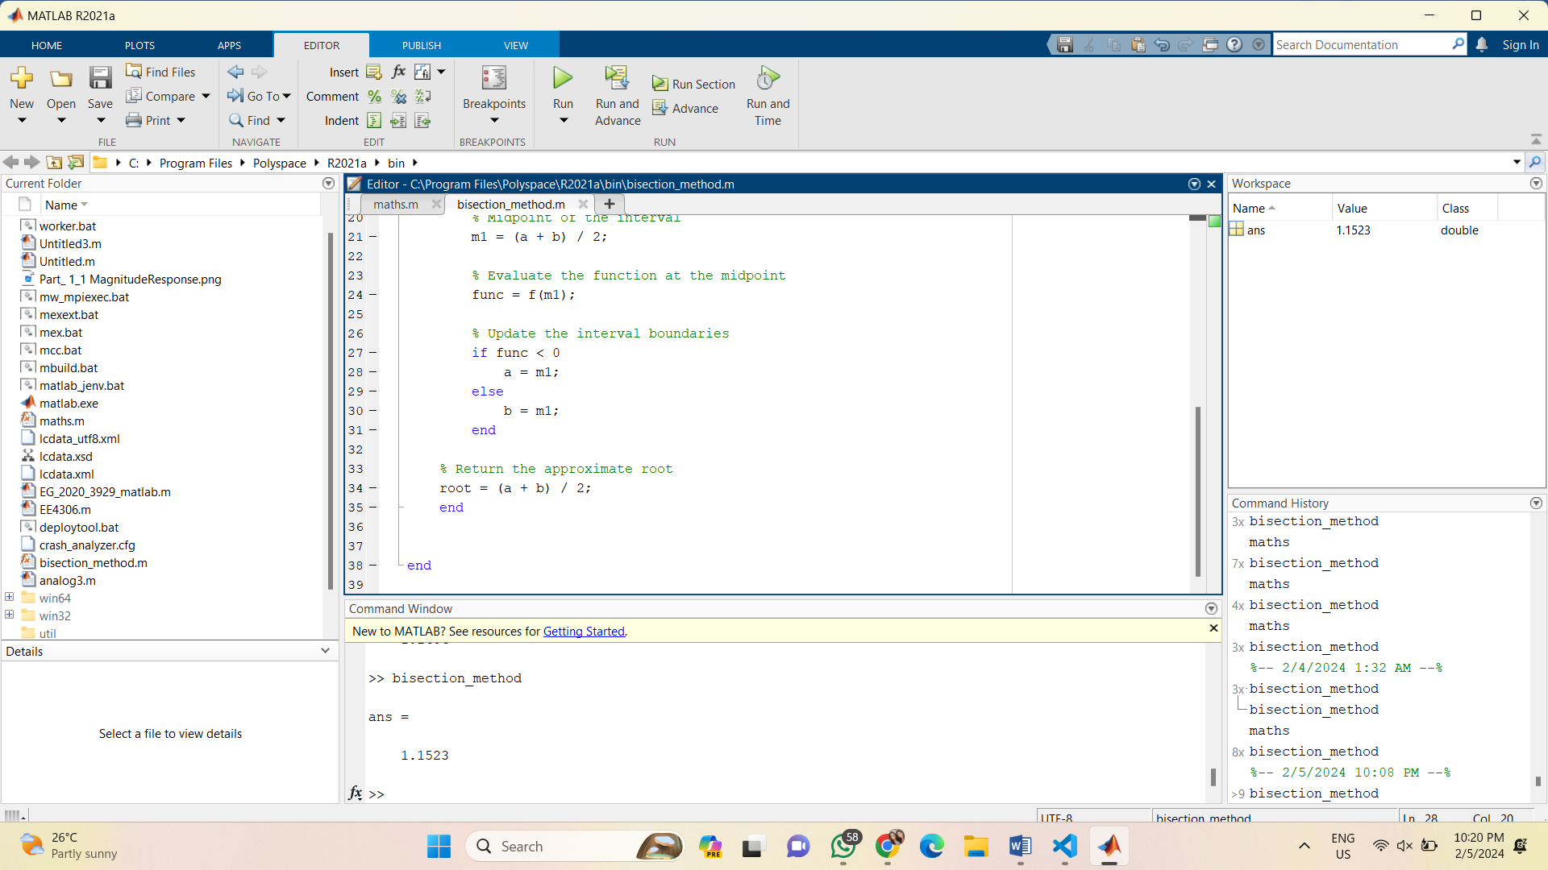 The result,

Figure : RESULTS

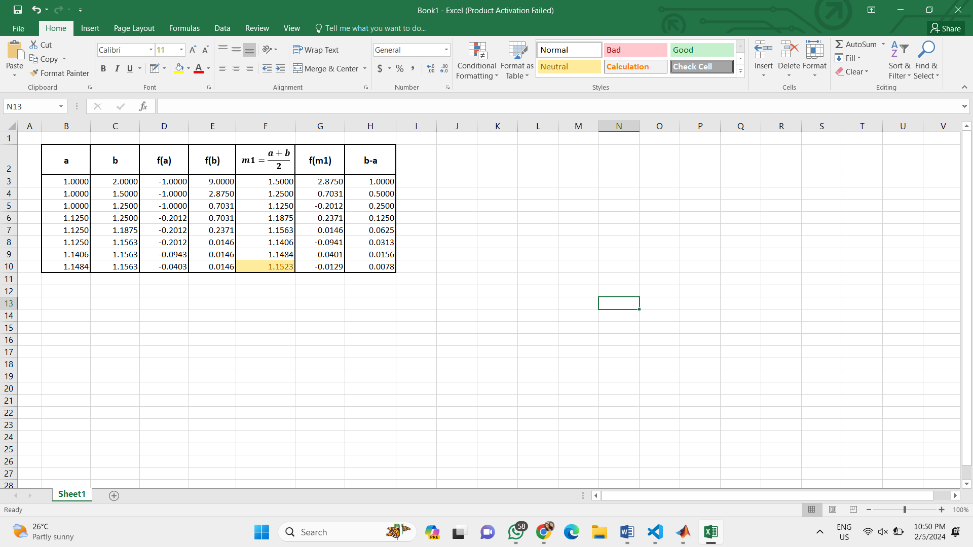Root for above equation by tabular method,

Figure : RESULTS BY MANUAL METHOD